
CY104L – Introduction to Cybersecurity
LAB # 04
Netstat (Network Statistics)

––
Student Name: Athar Imran
Student ID: 2604277

Assignment Date: 01 October, 2026
Assignment done: 27th September, 2026
Due Date: 02nd October, 2026

Netstat
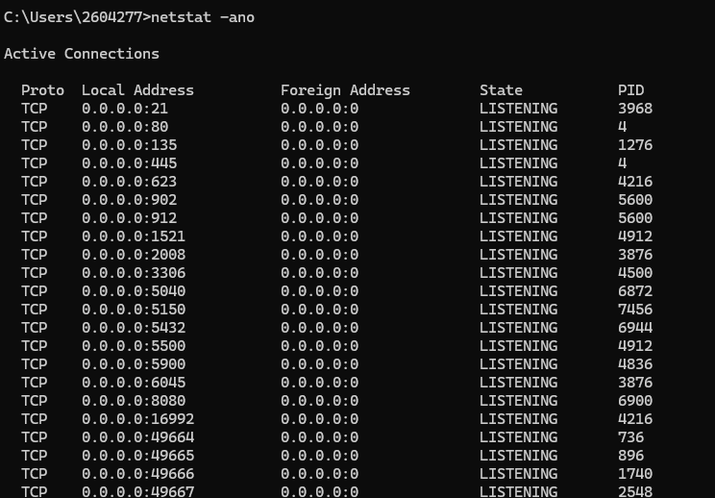
Program with PID:
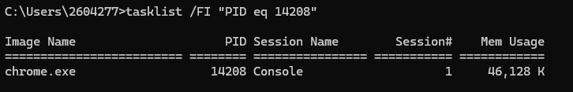
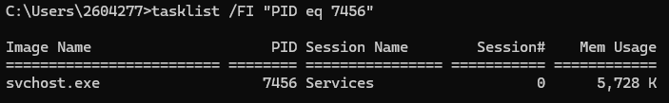
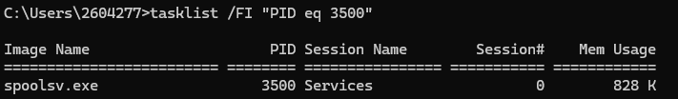
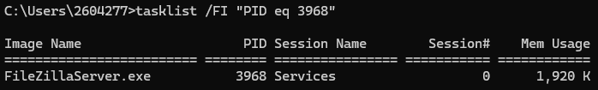
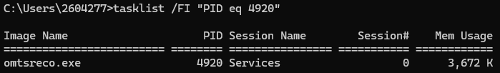

No. | Proto | Local Address | Foreign Address | State | PID | Application
1 | TCP | 172.30.2.29:50755 | 142.251.37.78:443 | ESTABLSHED | 14208 | Chrome.exe
2 | TCP | 0.0.0.0:5150 | 0.0.0.0:0 | LISTENING | 7456 | svchost.exe
3 | TCP | 0.0.0.0: 49668 | 0.0.0.0:0 | LISTENING | 1276 | spoolsv.exe
4 | TCP | 0.0.0.0: 21 | 0.0.0.0:0 | LISTENING | 3698 | FileZilaServer.exe
5 | TCP | 127.0.0.1:2030 | 0.0.0.0:0 | LISTENING | 4920 | Omtsreco.exe

Nslookup
